The Kinect sensor is a flat, black box that sits on a small platform when placed on a table or shelf near the television you're using with Xbox 360. This device has the following three sensors that we can use for vision and robotics tasks:

-A color VGA video camera to see the world in color

-A depth sensor, which is an infrared projector and a monochrome CMOS sensor working together, to see objects in 3D

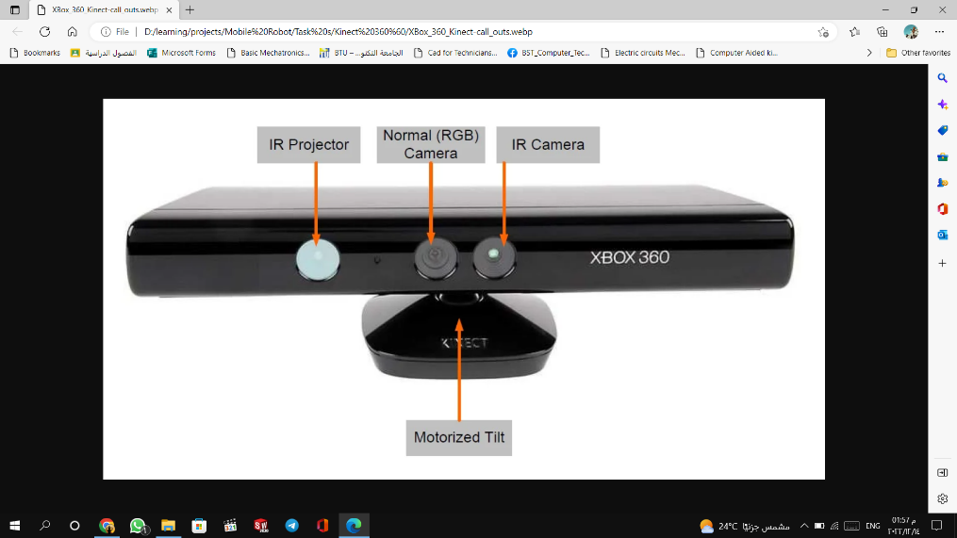-A multiarray microphone that is used to isolate the voices of the players from the noise in the room.

At the first, we have to remember Kinect has been created for full body tracking in

a room-like environment (that's means: indoor sensor) Not designed to work in the presence of sunlight.

The Kinect sensor has a practical ranging limit of 1.2–3.5 m (3.9–11 ft) distance when used with the Xbox software. The area required to play Kinect is roughly 6m², **although the sensor can maintain tracking through an extended range of approximately 0.7–6 m.**

kinect normal connection:

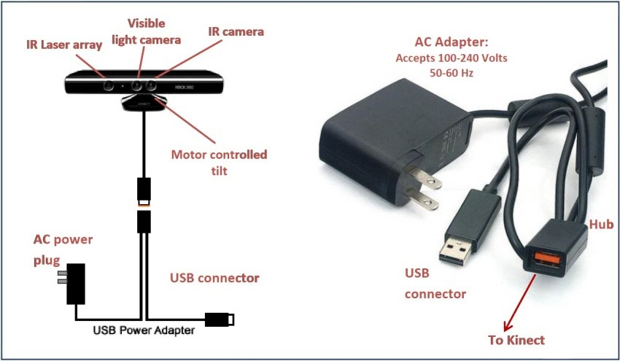

we will place the adaptor with the battery.

**But how !!?**

**Lets know How to connect the kinect with battery (make it portable):**

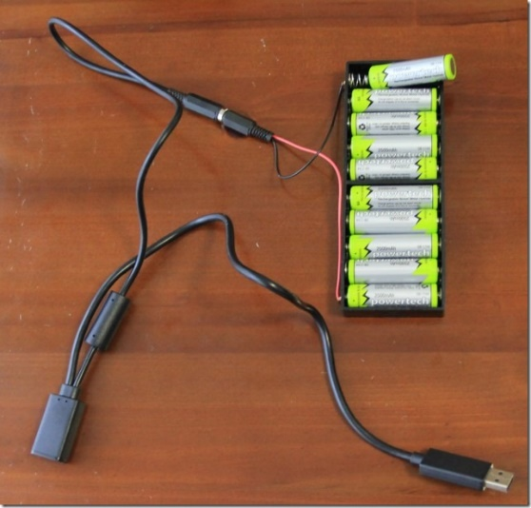

Just cut the cable between the power adaptor and the Kinect connector (not the USB connector). Split the cable in the two wires and strip a small end of them.

Go to the local electronics store and ask for cage clamps, just make sure you have the ones for flexible cable types, not the ones for solid cable.

Connect the – (negative terminal ) from the battery to the white cable from the kinect and the + (positive terminal) from the battery (or robot) to the brown one and you are ready without doing any soldering.

kinect

Computer \raspberry pi

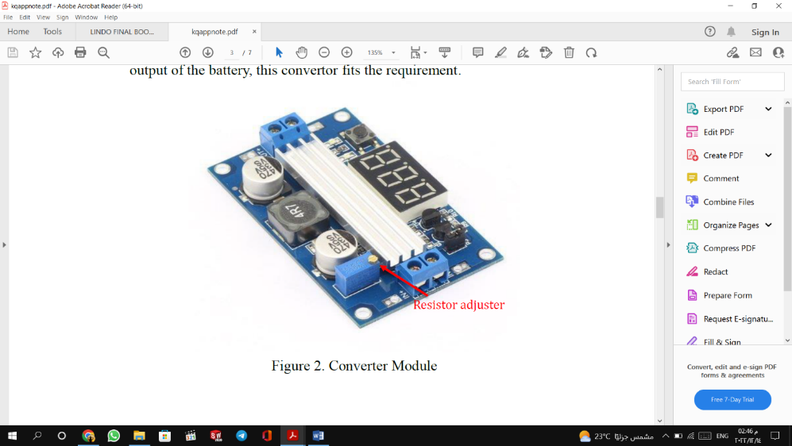If you get here, please hear the audio in the group.

Some stores have this component:

<https://electra.store/product/boost-step-up-power-converter-module-xl6009-dc-dc-4a/>

<https://microohm-eg.com/product/mt3608-2a-max-dc-dc-step-up-power-module-booster-power-module/>

Software steps :

* <https://www.youtube.com/watch?v=_QpNMJEAkX0&ab_channel=RoboticsWeekends>
* <https://www.hackster.io/dmitrywat/rgb-d-slam-with-kinect-on-raspberry-pi-4-ros-melodic-ace795>
* <https://answers.ros.org/question/30473/ros-kinect-programming-tutorial/>

**Some problems and it solves:**

<https://answers.ros.org/question/196455/kinect-installation-and-setup-on-ros-updated/>

<https://www.facebook.com/groups/185984788460258/permalink/1705250436533678/>

Kinect components:

<https://www.allaboutcircuits.com/news/teardown-tuesday-microsofts-xbox-360-kinect/>